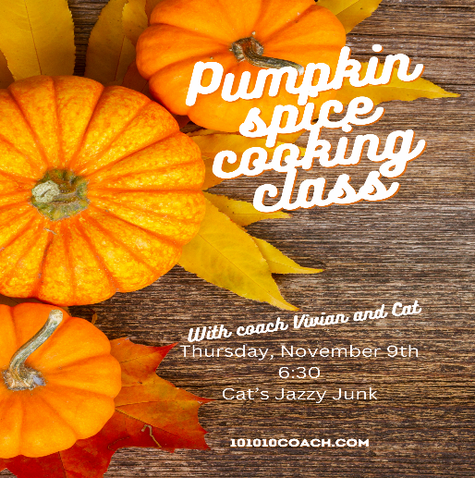

CARAMEL APPLE CIDER MIMOSA

Caramel sauce

Cinnamon Sugar

4 ounces apple cider

2-4 ounces prosecco or champagne chilled

Apple slices

Dip the rim of the glass in caramel and then into cinnamon sugar. Pour in the apple cider and top with prosecco. Garnish with apple slice.

SQUASH SOUP
2 Cups chicken or vegetable broth
2 Cups cooked butternut squash (see notes)
1/4 onion peeled and chopped
1/4 medium apple seeded and chopped
1/4 t nutmeg
1/4 t dried sage
1/4 t dried rosemary
1/8 t white pepper
1/2 t salt
1/4 C heavy cream-may substitute coconut milk for detox or vegan version

Sautee onion and apple together in Dutch-oven or instant pot until tender. Add in squash, seasonings and broth and heat through. Pressure cook 10 minutes in Instant Pot then release pressure. Turn off heat and add cream.

Blend soup with hand blender or potato masher until desired consistency. May also blend in stand blender, however, soup will be thin.
Serve and top with roasted pepitas or popcorn.

Notes
To cook squash:
steam or microwave diced squash until tender (10-15 minutes).
roast in oven: Poke holes in squash with a fork. Roast whole squash on baking sheet until tender (about 60 minutes).

FALL SALAD WITH APPLE CIDER VINEGARETTE

¼ c Apple Cider Vinegar

2 TBSP Honey or Maple Syrup

1 tsp. Dijon mustard

1-2 cloves garlic-minced

¼ tsp kosher salt

¼ tsp white pepper

1/3 C olive oil

Wisk together apple cider vinegar, honey, mustard, garlic, salt and pepper.

Wisk in the olive oil in a steady stream until smooth and incorporated.

Chill and serve

Serve with mixed salad greens, chopped apples, red onion, dried cranberries, pomegranate seeds and top with crumbled goat or feta cheese.

PUMPKIN ENERGY BALLS

3 Cups dry uncooked oats

15 oz pure pumpkin puree

½ C natural peanut butter

½ C pure maple syrup or honey

1 TBSP coconut oil, melted

½ teas. Pumpkin pie spice

1 Cup pumpkin seeds

½ C mini chocolate chips or vanilla chips

Mix all ingredients together. Roll into balls and freeze for 3 hours until set.

Thank you for joining us!! Let’s keep in touch!

101010Coach.com Vivian Sickels

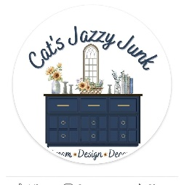 Catsjazzyjunk.com Cat Smith

